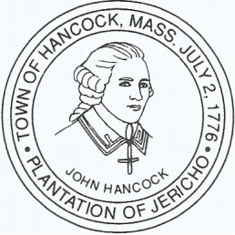

TOWN OF HANCOCK
3650 HANCOCK ROAD HANCOCK, MASSACHUSETTS 01237 413-738-5225 FAX 413-738-5310

Town of Hancock Solicitation Application

Date/Time of Requested Solicitation _____________________
Applicant (sales agent) –
Name _____________________
Address _____________________
Cell Phone Number _____________________
Email Address _____________________
Vehicle Tag Number/State _____________________
Vehicle Make/Model/Color _____________________
Length Of Employment _____________________
Company –
Name _____________________
Address _____________________
Product Being Sold _____________________
Supervisor’s Name/Title _____________________
Supervisor’s Phone Number _____________________
Supervisor’s Email Address _____________________

• Application must be received at least 5 business prior to requested
solicitation
• Solicitation allowed Monday-Friday 10am-7pm, no solicitation of
holidays and weekends
• Sales agent must wear company provided photo identification that is
clearly visible at all times (town vendor card?)
• Sales agent’s vehicle must display company name and the word “sales”
that is clearly visible from a distance.
• Company must have a criminal background check policy and provide
proof that the sales agent has no sexual offense, other felony

convictions or misdemeanor convictions for theft or drug use. Email
confirmation to hancockmapd@gmail.com

