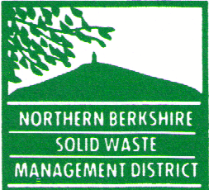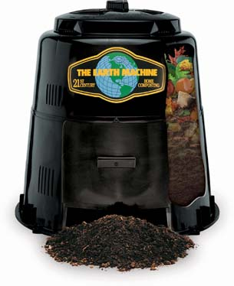
Earth Machine, 80-gallon Home Compost Bin
Saturday, May 30, 2020
10am to 12:00pm
Location: Whitney’s Farm, 1775 South State St, Cheshire
The District is offering Home Composting Bins for sale to Berkshire County residents while supplies last. Earth Machines 80-gallon unit. $43.00 Does your town offer a Subsidy?
Question lcernik@nbswmd.com or call 413-743-8208 Linda Cernik, to place your order.
One per Household. Limited supply.

Please practice social distancing and wear a mask, Thank you.

